A

## Project Report

on

**GSM Based Home Security Alarm System Using Arduino**

Submitted for Partial Fulfillment of

the Requirements of the Degree

of

## Bachelor of Technology

in

## Electronics and Tele-communication Engineering

to

## G H Raisoni Institute of Engineering and Business Management, Jalgaon

Submitted by

### Harshal Hemant Mahajan

### Kalpesh Krushnarao Patil

### Aadesh Sharad Chaudhari

### Adesh Sudhakar Mhaske

Under the Guidance of

### Mr. Deepak Khadse

# Raisoni Logo

**DEPARTMENT OF ELECTRONICS AND TELE-COMMUNICATION ENGINEERING**

G H Raisoni Institute of Engineering and Business Management,

Jalgaon - 425002 (MS)

2024– 2025

## G H RAISONI INSTITUTE OF ENGINEERING AND BUSINESS MANAGEMENT, JALGAON

**DEPARTMENT OF ELECTRONICS AND TELE-COMMUNICATION ENGINEERING**

**CERTIFICATE**

This is to certify that the project entitled “**GSM Based Home Security Alarm System Using Arduino*”***, submitted by

### Harshal Hemant Mahajan

### Kalpesh Krushnarao Patil

### Aadesh Sharad Chaudhari

### Adesh Sudhakar Mhaske

in partial fulfillment of the degree of *Bachelor of Technology* in **ELECTRONICS AND TELE-COMMUNICATION ENGINEERING** *Engineering* has been satisfactorily carried out under my guidance as per the requirement of G H Raisoni Institute of Engineering and Business Management, Jalgaon.

**Date:**

**Place:** Jalgaon

#### HOD Guide

**Examiner Dean Academics Director**

**EXAMINER’S CERTIFICATE**

This is to certify that the project report titled **“GSM Based Home Security Alarm System Using Arduino”** , submitted by following students has been approved In partial fulfilment of final year degree course in Electronics And Telecommunication Engineering as prescribed G H Raisoni Institute of Engineering Management, Jalgaon.

External Internal

**Date:-**

**Place:-** G H Raisoni College of Engineering and Management, Jalgaon.

**Harshal Hemant Mahajan Kalpesh Krushnarao Patil**

**Aadesh Sharad Chaudhari Adesh Sudhakar Mhaske**

**ACKNOWLEDGEMENTS**

I take this opportunity to express my gratitude to all those who have rendered co-operation and guidance that supported me while developing this project work. This is the right moment to express my sincere gratitude towards my **guide Prof. Deepak Khadse Sir** For his/her valuable guidance and prescriptive suggestions at every stage during the project work. I thank from bottom of my heart to **Dr. Tushar Patil ,** Head of Department who has been a great source of moral and timely support for completing this project work. I would also like to thank our Honorable Director**, Dr. Preeti Agarwal** madam for her motivation and support. I also take the opportunity to thank **Dr. Sanjay Shekhawat** sir for his warm support. Last but not the least I express my inner gratitude to all my respected teachers, my group members and friends for their everlasting support.

### I, Harshal H. Mahajan, along with my teammates, Kalpesh K. Patil and Aadesh S. Chaudhari, Adesh Sudhakar Mhaske deeply appreciate the collaboration and dedication that each one of us has contributed to this project.

|  |  |  |
| --- | --- | --- |
|  |  | Harshal Hemant Mahajan |
|  |  | Kalpesh Krushnarao Patil |
|  |  | Aadesh Sharad Chaudhari |
|  |  | Adesh Sudhakar Mhaske |
|  |  |  |

**LIST OF FIGURES**

**Fig No. Fig Name Page No**

# Fig 2.1 IR Sensor Module 08

# Fig 2.2 IR Sensor Circuit 09

# Fig 2.3 GSM Module 10

# Fig 2.4 Arduino UNO 11

# Fig 3.1 System Design 16

# Fig 3.2 Circuit Block Diagram 17

# Fig. 3.3 Flowchart 23

# Fig. 3.4 Flowchart 24

# Fig 3.5 Model 26

# Fig 3.6 Components 27

**CONTENTS**

* Acknowledgements
* List Of Figures
* Abstract
* Chapter 1

Introduction

* 1. **Concept of Project**
  2. **Aim Of Project**
  3. **Purpose Of Project**
  4. **Project Objective**
  5. **Summary**
* Chapter 2

System Overview

* 1. **IR Sensor**
  2. **GSM Module**
  3. **Arduino Microcontroller**
* Chapter 3

System Design

* 1. **System Architecture**
  2. **Flowcharts**
  3. **Software**
  4. **Programming**
  5. **Implementation and Working**

**3.4 Hardware Components**

* Chapter 4

**Conclusion**

**References**

**Certifications**

ABSTRACT

This paper presents the development of a GSM-based home security alarm system integrated with an infrared (IR) sensor for intruder detection. The proposed system leverages the IR sensor to detect motion or the presence of an unauthorized individual within a defined area. Upon activation, the sensor triggers a microcontroller, which processes the input signal and initiates the alarm. Concurrently, the system utilizes a GSM module to send an SMS alert to the homeowner or a designated recipient, ensuring real-time notification of a potential security breach. This approach combines advanced sensor technology with wireless communication to provide an effective, cost-efficient, and scalable solution for home security. The system is designed to be easily deployable, reliable, and capable of offering remote monitoring, thus enhancing the safety of residential environments. The integration of GSM technology ensures prompt alerts, even when the homeowner is away from the premises, offering continuous surveillance and peace of mind.

**Keywords:** GSM, Home Security, Alarm System, Infrared Sensor, Microcontroller, SMS Notification, Intruder Detection, Wireless Communication

CHAPTER 1

INTRODUCTION

The usefulness and advantages of home security systems have been clearly demonstrated by their ability to provide immediate monitoring of a home. The rising number of burglaries and home thefts has heightened the need for such systems, making homeowners more vigilant. Traditional security systems based on CCTV are not real-time, as they only alert the owner after an incident has occurred, unless the owner is present at the time. An innovative home system comprises a sophisticated network of interconnected devices, including sensors, actuators, communication devices, and computing devices. These systems are designed to offer a range of services and applications with minimal intervention, including safety and security measures, automation, entertainment, and energy management. Among these services, intelligent home safety and security systems are of particular importance due to the increasing need for people to feel secure in their homes and mitigate crime risk. The advent of cutting-edge technologies such as the Internet of Things (IoT), compact microcontrollers, and affordable sensors and actuators has opened up new possibilities for implementing safety and security features in intelligent homes. These systems play a crucial role in monitoring indoor environments, providing homeowners with real-time updates and alerts when potentially harmful situations arise, even when they are away from home. The primary objective is to analyze data collected from sensors in the surrounding environment and trigger appropriate actions through actuators to address or prevent potential threats. Many researchers are working to create custom-based security solutions that are affordable for everyone to address this issue effectively. In this situation, we aim to develop a security system that makes life easier and ensures people feel secure when they are not at home. With the increase in movement and activity, people need a reliable security solution. Our system uses cell phone technology to provide quick and easy access to information, helping homeowners stay informed about their home's security in real time.

In the modern era, ensuring the safety and security of our homes, assets, and loved ones is more critical than ever. With increasing urbanization and busy lifestyles, people often find themselves away from home for extended periods, whether for work, travel, or other commitments. This creates a vulnerability to burglaries and break-ins. Traditional security measures, such as manual locks and physical surveillance, may no longer suffice in providing complete protection. The evolution of technology, however, offers new solutions for home security, combining affordability, ease of installation, and real-time monitoring. This project aims to design and implement a **GSM-based home security system** integrated with an **Infrared (IR) sensor** to address these concerns effectively.

The primary objective of the proposed system is to detect unauthorized entry into a home, alert the homeowner remotely, and trigger an immediate response. The system utilizes advanced motion-detection technology through the IR sensor, coupled with a GSM module to send SMS notifications. The use of GSM allows homeowners to be notified about a potential security breach in real-time, even if they are far away from home. The integration of these technologies ensures that the security system is both efficient and accessible, offering peace of mind to users.

* 1. **Concept of Project**

A GSM-based home security system is a practical and cost-effective way to monitor your home or office for intrusions or unauthorized movements. By integrating an IR (Infrared) sensor with an Arduino, you can detect motion and trigger real-time alerts via an SMS sent through a GSM module. In this detailed explanation, we will explore the components, working mechanism, system design, and step-by-step working of the system.

**1.2 Aim Of Project**

The aim of the GSM-based home security system using an IR sensor is to provide an affordable, reliable, and efficient solution for detecting unauthorized access or intrusions in homes or offices. By integrating an Arduino microcontroller, a PIR (Passive Infrared) sensor, and a GSM module, the system detects motion and sends real-time SMS alerts to the homeowner, ensuring prompt notification of any security breach.

The PIR sensor detects changes in infrared radiation from warm bodies, triggering the Arduino to activate an alarm (e.g., buzzer or siren) and send an SMS alert to a predefined mobile number. This enables remote monitoring and immediate response, even when the user is away from the property.

Designed for cost-effectiveness and ease of use, the system leverages inexpensive components and simple installation, making it accessible to users with minimal technical knowledge. The system is also scalable, allowing for additional sensors or features to be added as needed. Ultimately, the project aims to provide an efficient, low-cost security solution that offers real-time alerts and remote monitoring, enhancing home and office security with minimal setup and ongoing costs.

* 1. **Purpose Of Project**

The purpose of the GSM-based home security system using an IR sensor is to create an affordable, reliable, and user-friendly solution for detecting unauthorized access in homes, offices, or other properties. By utilizing a PIR (Passive Infrared) sensor, the system detects motion caused by the presence of humans or animals and triggers an alarm (buzzer or siren). Simultaneously, it sends an SMS notification via a GSM module to alert the homeowner or security personnel in real-time, even when they are away.

Using an Arduino microcontroller, the system offers a low-cost, easily programmable alternative to traditional security systems, making it accessible to a wide range of users. The project aims to improve property security, provide instant alerts, and enable remote monitoring, while being scalable, simple to set up, and budget-friendly for individual homeowners and small businesses.

* 1. **Project Objective**

The objective of the GSM-based home security system using an IR sensor is to develop an affordable, efficient, and reliable solution for detecting unauthorized motion and intrusions in real-time. The system is designed to provide immediate alerts to property owners or security personnel, enabling them to take swift action and enhance the safety of their homes, offices, or businesses.

By integrating a PIR (Passive Infrared) sensor, an Arduino microcontroller, and a GSM module, the system detects movement caused by warm bodies (such as humans or animals) within a monitored area. When motion is detected, the system activates a local alarm (e.g., buzzer or siren) and sends an SMS alert to a predefined mobile number. This allows users to remotely monitor and respond to security threats, even when they are not on-site.

The project aims to offer a cost-effective alternative to traditional security systems, making it accessible to homeowners and small businesses. It is designed to be scalable, easy to install, and user-friendly, providing a reliable security solution that is simple to set up and use, even for individuals with limited technical expertise. Ultimately, the system strives to enhance property security while maintaining affordability and ease of use.

* 1. **Summary**

The GSM-based home security system using an IR (PIR) sensor is an affordable, efficient, and reliable solution designed to detect unauthorized motion and intrusions in real-time. By integrating a PIR sensor, an Arduino microcontroller, and a GSM module, the system detects movement caused by warm bodies (e.g., humans or animals) and triggers an alarm (such as a buzzer or siren). Simultaneously, it sends an SMS alert to a predefined mobile number, allowing users to monitor and respond to security threats remotely.

This system provides a cost-effective alternative to traditional security systems, offering a scalable, easy-to-install, and user-friendly solution. It is designed to enhance property security for homeowners and small businesses while being accessible to users with minimal technical expertise. The system aims to improve safety, deter intruders, and provide peace of mind with real-time alerts, all while maintaining simplicity and affordability

CHAPTER 2

SYSTEM OVERVIEW

The home security system employs two primary components: Infrared (IR) sensors and a GSM module. The IR sensor is used to detect motion, while the GSM module facilitates communication with the homeowner by sending real-time SMS alerts when movement is detected.

**IR Sensor**

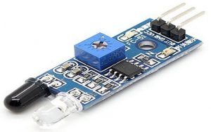

**Fig 2.1 IR Sensor Module**

The **IR sensor** is the core technology for detecting motion within a defined area. IR sensors detect infrared radiation emitted by objects in their line of sight, typically in the form of heat signatures. These sensors are highly effective for detecting movement in low-light environments, making them ideal for home security systems.

When a person or object enters the sensor’s detection range, it detects a change in infrared radiation, signaling that motion has occurred. Once motion is detected, the sensor sends a signal to the **Arduino microcontroller**, which processes the signal and activates the alarm.

* **Range and Sensitivity:** The IR sensor is capable of detecting movement within a range of up to **6 meters (approximately 20 feet)**. The sensor’s sensitivity is adjustable to minimize false detections, ensuring that it only triggers when there is significant motion.
* **Advantages of IR Sensors:** Unlike passive infrared (PIR) sensors, which detect motion based on body heat, IR sensors can detect motion from any object that reflects infrared radiation. This makes them highly versatile for different environments, such as detecting movement from windows, doors, or intruders.

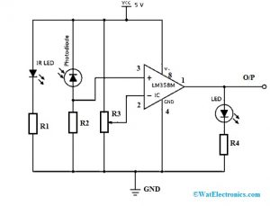

**Fig 2.2 IR Sensor Circuit**

The application circuit of the IR sensor is an obstacle detecting circuit that is shown below. This circuit can be built with a photodiode, IR LED, an [Op-Amp](https://www.watelectronics.com/what-is-an-op-amp-differentiator-circuit-its-working/), LED & a potentiometer, The main function of an infrared LED is to emit IR light and the photodiode is used to sense the IR light. In this circuit, an operational amplifier is used as a voltage comparator and the output of the sensor can be adjusted by the potentiometer based on the requirement.

Once the light generated from the infrared LED can be dropped on the photodiode once striking an object, then the photodiode’s resistance will be dropped.

Here, op-amp’s one of the input at threshold value can be set through the potentiometer whereas other inputs can be set by using the series resistor of the photodiode. Once the radiation on the photodiode is more, then the voltage drop will be more across the series resistor. In the operational amplifier, both the voltages are evaluated.

If the series resistor’s voltage is higher than the threshold voltage then the IC output is high. When the IC output is given to an LED then it will blink. So, using a potentiometer, the threshold voltage can be adjusted based on the conditions of surroundings.

In this circuit, the arrangement of the IR receiver and the IR LED is a very essential factor. Once the infrared LED is placed directly ahead of the infrared receiver, then this arrangement can be known as Direct Incidence.

So, in this case, nearly the whole radiation from the infrared LED will drop on the infrared receiver. Therefore, there is a row of view contact among the IR Tx & Rx. If a target drops in this row, it blocks the emission while approaching the receiver by reproducing or absorbing the radiation.

**GSM Module**

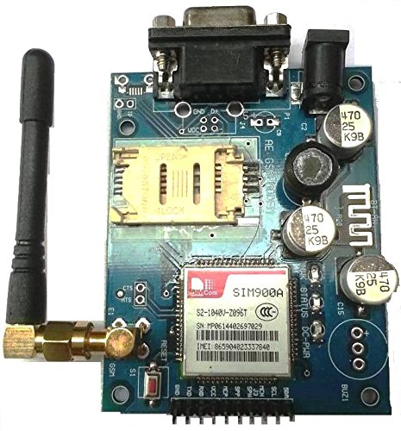

**Fig 2.3 GSM Module**

The **GSM module** is a wireless communication system that connects the security system to the mobile network. Once motion is detected by the IR sensor, the **Arduino microcontroller** processes the signal and triggers the GSM module to send an SMS notification to the homeowner or a designated contact number. The GSM module operates on cellular networks, ensuring that the homeowner can receive alerts from anywhere, as long as they have mobile network access.

* **Remote Monitoring:** The key advantage of using a GSM module is that it enables remote monitoring of the security system. Homeowners are notified instantly through SMS about any suspicious activity. This is especially useful when the homeowner is on vacation, at work, or away from home for any other reason.
* **Two-way Communication:** The GSM module also allows for two-way communication, enabling the homeowner to interact with the system remotely. For instance, if the system triggers an alarm due to motion detection, the homeowner can deactivate the alarm remotely by sending a predefined SMS command to the system, stopping the false alarm.

**Arduino Microcontroller**

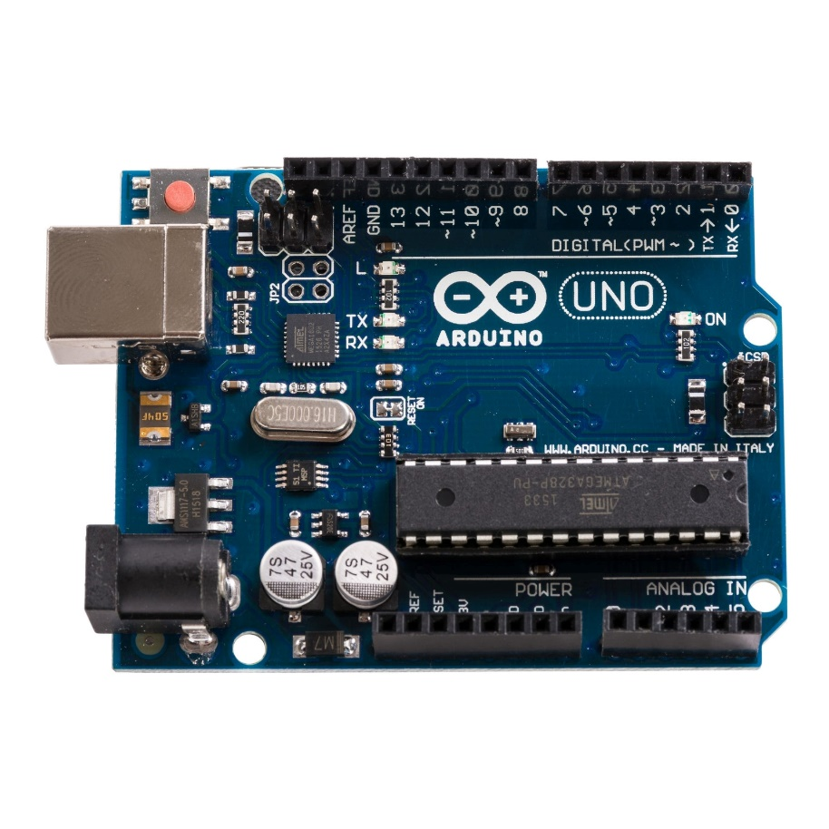

**Fig 2.4 Arduino UNO**

The **Arduino Uno** acts as the **central controller** of the system, processing data from the IR sensor and managing the communication with the GSM module. It is the brain of the system, handling logic, decision-making, and communication processes.

* **Processing Input Signals:** When the IR sensor detects motion, it sends an output signal to the Arduino. The microcontroller processes this input, evaluates whether the motion is significant enough to trigger an alarm, and activates the alarm mechanism if necessary.
* **SMS Notification:** Once the motion is confirmed, the Arduino sends a signal to the GSM module to initiate the SMS alert. The pre-programmed mobile number receives an SMS detailing the detection, enabling the homeowner to take action.
* **Scalability and Flexibility:** The use of an open-source platform like Arduino makes the system highly **scalable and flexible**. New sensors, such as additional IR sensors or other security components, can be added to the existing system, allowing users to expand and customize their security setup based on their needs.

CHAPTER 3

SYSTEM DESIGN

**System Architecture**

In the **GSM-based home security system**, the key components work together seamlessly to detect motion, trigger alarms, and provide real-time alerts. Here’s a description of each of the main components and their roles:

**1. IR Sensor:**

The IR sensor is responsible for detecting motion within its detection range. It works by emitting infrared light and measuring how much of that light is reflected by objects in its path. When a warm body (such as a person or animal) enters the sensor's range, it causes a change in the amount of infrared radiation reflected back. This change is detected by the sensor, which then sends this data to the Arduino microcontroller. The PIR (Passive Infrared) sensor typically has a detection range of around 6 meters (20 feet) and can be mounted at entrances or areas that need monitoring.

**2. Arduino Uno:**

The Arduino Uno acts as the brain of the system. It receives the motion detection signal from the IR sensor and processes the data to determine if there is a valid security threat. Once motion is detected, the Arduino decides whether to trigger the alarm based on predefined conditions. If it detects movement, it sends a signal to the GSM module to alert the homeowner. Additionally, the Arduino is responsible for managing the overall operation of the system, including controlling any connected peripherals, like the buzzer or siren for local alerts, and handling the communication with the GSM module.

**3. GSM Module:**

The GSM module is a crucial component of the GSM-based home security system, enabling real-time communication between the system and the homeowner. When the Arduino receives a signal from the IR sensor detecting motion, it triggers the GSM module to send an SMS alert to a predefined mobile number. The message provides details about the detected motion, such as "Motion detected at the front door," helping the homeowner identify the location of the potential security breach.

The GSM module connects to a cellular network via a SIM card and supports various GSM protocols, ensuring compatibility with different mobile networks. This allows the system to send SMS alerts to the homeowner’s mobile phone, regardless of their location, as long as there is mobile network coverage (2G, 3G, or 4G).

The system can be further customized to send different types of alerts, such as system status or power failure notifications. By integrating the GSM module, the security system enables remote monitoring and control, providing homeowners with immediate, actionable notifications and enhancing the overall effectiveness of property protection.

**4. Mobile Phone:**

The mobile phone receives an SMS alert from the GSM module, providing the homeowner with immediate notification of any security breaches, even when they are off-site. In addition to the SMS, the GSM module can also place an automated phone call to ensure the homeowner is promptly informed of potential intrusions. This dual-channel alert system—via both SMS and phone call—ensures that the homeowner receives timely notifications, regardless of whether they prefer text or voice communication.

Additionally, the system supports two-way communication, allowing the homeowner to send SMS commands back to the system. For instance, in the event of a false alarm, the homeowner can remotely deactivate the alarm or adjust system settings as needed. This feature provides greater flexibility, enabling the homeowner to manage the security system from anywhere, without the need for physical access to the property.

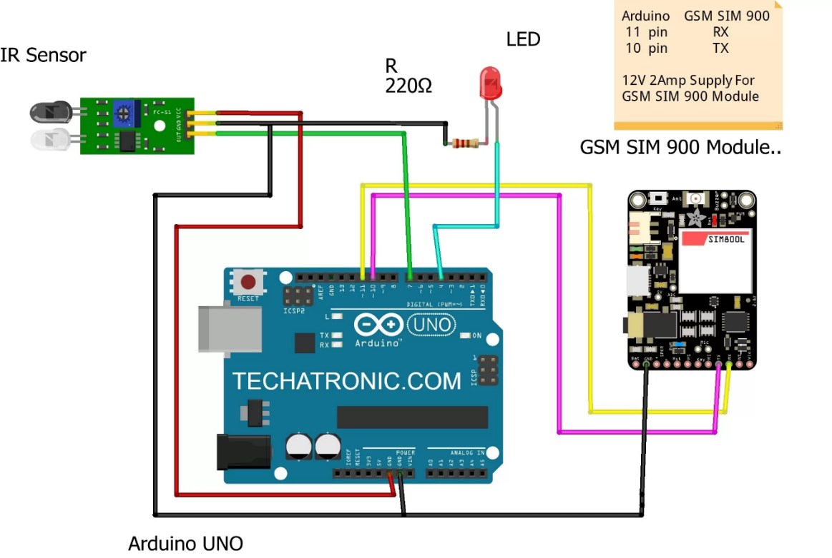

**Fig 3.1 System Design**

**Circuit Block Diagram**

z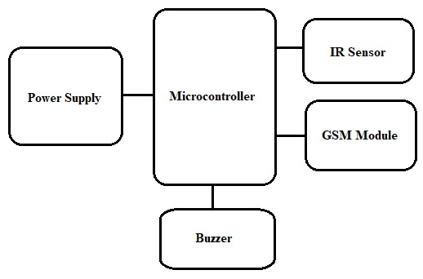

**Fig 3.2 Circuit Block Diagram**

**Software**

We have used Arduino, which is an open-source platform encompassing software, hardware, and a vibrant user community. Arduino designs and manufactures microcontroller tools that enable the creation of digital devices and interactive objects capable of sensing and controlling physical elements. These tools are user-friendly and highly programmable, catering to a wide range of applications from hobbyist projects to professional designs.

In this project, we have constructed a specific algorithm to monitor both the mobile phone and the IR sensor using Arduino, programmed through the Arduino IDE (Integrated Development Environment). The system leverages Arduino software to develop and refine the code for the Arduino controller, allowing seamless integration and operation.

The Arduino Uno, a microcontroller board based on the ATmega328P, serves as the core of our system. It features 14 digital input/output pins, 6 analog inputs, a 16 MHz quartz crystal, a USB connection, a power jack, an ICSP header, and a reset button. These features make the Arduino Uno highly versatile and suitable for a wide array of applications.

The Arduino Uno can be programmed with the Arduino software, which is based on the Processing programming language and provides an easy-to-use environment for writing code. This environment supports a variety of programming languages and libraries, allowing for extensive customization and functionality enhancements.

Our system utilizes the Arduino Uno to manage and control the IR sensor, which detects motion by sensing infrared radiation emitted by surrounding objects. When motion is detected, the Arduino processes this information and communicates with the GSM module to send alerts to the user's mobile phone.

**The use of Arduino in this project offers several advantages:**

**Flexibility:** The open-source nature of Arduino allows for continuous development and customization, ensuring the system can evolve with new features and capabilities.

**Community Support:** The extensive Arduino community provides a wealth of resources, including tutorials, forums, and libraries, which facilitate troubleshooting and innovation.

**Cost-Effectiveness:** Arduino boards and components are relatively inexpensive, making them accessible for a wide range of users and projects.

**Ease of Use:** The Arduino IDE and its user-friendly programming language make it easy for users, even those with limited programming experience, to develop and modify their projects.

By leveraging the capabilities of Arduino, our system offers a robust and efficient solution for home security, providing real-time monitoring and notifications to ensure the safety of the home and its occupants.

**Programming :**

#include <SoftwareSerial.h>

// GSM module on pins 13 (RX) and 12 (TX)

SoftwareSerial SIM900A(13, 12);

// PIR sensor connected to pin 7

const int PIR_PIN = 7;

const int buzzer = 8;

// Phone number to send SMS (replace with your number)

const char phoneNumber[] = "+917020785727";

bool motionDetected = false; // To prevent duplicate SMS sending

void setup() {

// Initialize PIR sensor pin

pinMode(PIR_PIN, INPUT);

pinMode(buzzer,OUTPUT);

digitalWrite(buzzer,LOW);

// Initialize GSM module and Serial Monitor

SIM900A.begin(19200);

Serial.begin(19200);

// Allow GSM module to stabilize

delay(1000);

Serial.println("GSM Module Ready");

}

void loop() {

// Read the PIR sensor value

int sensorValue = digitalRead(PIR_PIN);

// If motion is detected

if (sensorValue == LOW && !motionDetected) {

Serial.println("Motion Detected!");

motionDetected = true; // Set flag to avoid sending multiple SMS

// Send SMS notification

sendSMS("Something is there");

digitalWrite(buzzer,HIGH);

delay(500);

digitalWrite(buzzer,LOW);

delay(500);

digitalWrite(buzzer,HIGH);

delay(500);

}

else if (sensorValue == HIGH) {

Serial.println("No Motion");

motionDetected = false; // Reset flag when no motion is detected

digitalWrite(buzzer,LOW);

}

delay(1000); // Check every second

}

// Function to send SMS using GSM module

void sendSMS(const char* message) {

Serial.println("Sending SMS...");

// Set GSM module to SMS text mode

SIM900A.println("AT+CMGF=1");

delay(1000);

// Send SMS command with phone number

SIM900A.print("AT+CMGS=\"");

SIM900A.print(phoneNumber);

SIM900A.println("\"");

delay(1000);

// Send SMS content

SIM900A.println(message);

delay(1000);

// End the message with Ctrl+Z (ASCII 26)

SIM900A.write(26);

delay(1000);

Serial.println("SMS Sent!");

}

**Flowchart:**

**Part One**

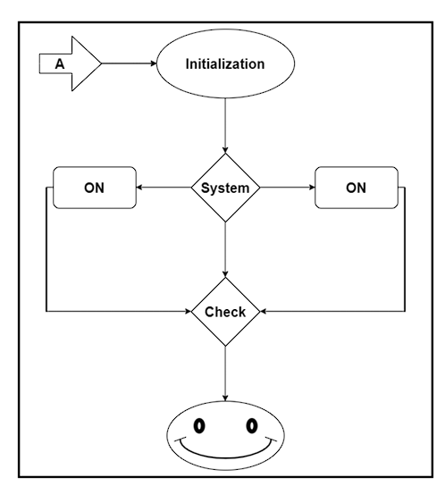

**Fig. 3.3 : Flowchart**

This flowchart illustrates the system's initiation process and how it checks all components. To enhance understanding, we have divided the entire system into two parts. One part describes the system's environmental startup procedure, while the other part details how messages are sent to the homeowner. It's crucial for the homeowner to ensure that the system is always active.

Fig. 3.2 : Flowchart - System Startup

Our system design in Part One monitors whether the system is ON or OFF. If the system is in OFF state, its main function is to activate the switch, thereby turning the system ON.

Home Security Alarm Systems play a vital role in today's society, where crime rates are rising. With recent technological advancements, homeowners no longer need to worry about their home's security while they are away. Modern home security systems provide extensive protection against burglars, smoke, fire, etc., and immediately alert the homeowner. The objective of this project is to implement a simple, yet effective home security alarm system. This system is designed to detect intruders and notify the homeowner via a phone call.

**Part Two:**

**Working of the Project**

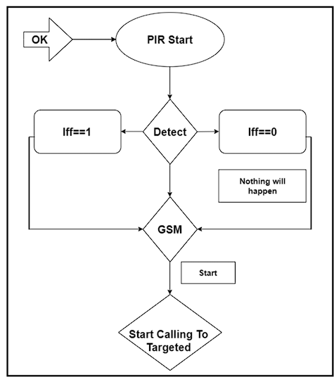

**Fig. 3.4 : Flowchart**

**The Working Of The Project Is Illustrated Below.**

An IR (Infrared) sensor is activated and can detect motion by identifying different infrared or radiant heat points emitted by neighboring objects. Generally, the IR sensor's output goes to a high level when it senses any motion. The coverage of a typical IR sensor is about 6 meters or around 30 feet.

To ensure the proper operation of the IR sensor, it requires a processing time of 20 to 60 seconds. This time is needed for the IR sensor's perching period, during which it calibrates to the surroundings and stabilizes the infrared detector. During this period, there should be minimal to no motion in front of the sensor. The IR sensor's output may not be reliable if it doesn't have sufficient time to calibrate.

When the IR sensor detects motion, its output becomes high. This is sensed by the Arduino, which then connects with the GSM module through serial transmission to initiate a call to the preprogrammed phone number.

It's important to note that the IR sensor's output will be high when it detects movement. However, the sensor's output may drop periodically even when there is movement, which might mislead the microcontroller into believing there is no movement. This issue should be addressed in the Arduino programming by ignoring brief low output signals and assuming continuous movement in front of the IR sensor.

**ALGORITHM AND PSEUDOCODE**

**Steps:**

1. START
2. Check if all modules are functioning properly.
3. When the IR (Infrared) sensor output is high.
4. Send a signal to the SIM900A module.
5. Take a few minutes to check the balance (Initialization).
6. Send an alert message to the host.

**Implementation and Working**

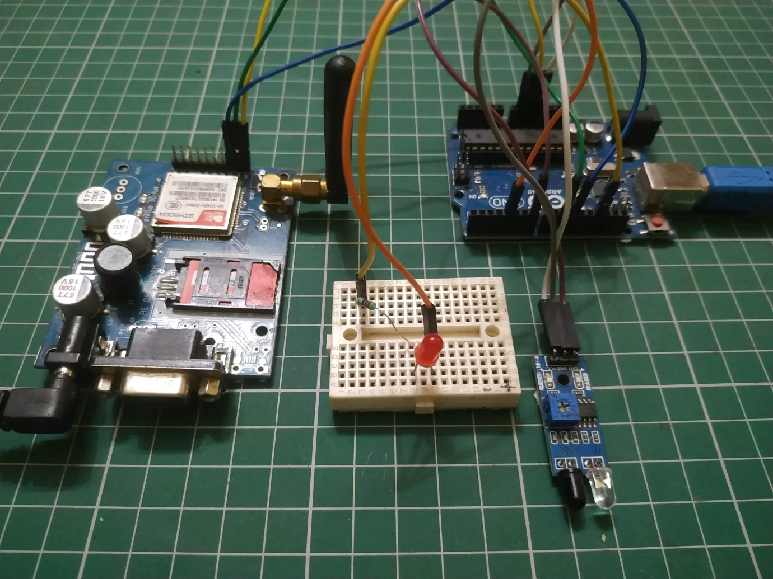

**Fig 3.5 Model**

Once the IR sensor detects motion, it sends a signal to the Arduino microcontroller. The Arduino then verifies whether the motion is significant enough to trigger the alarm. If a potential breach is detected, the Arduino instructs the GSM module to send an SMS notification to the homeowner. The SMS contains information regarding the detection, prompting the homeowner to act accordingly.

The system is programmed to filter out minor movements that may occur due to environmental factors (such as pets, wind, or small objects) to minimize false alarms. Only significant movement, such as a person entering the area, will trigger the alarm and SMS alert.

**Hardware Components**

* **Arduino Uno:** The central processing unit that handles inputs and outputs, manages system logic, and controls the overall operation.
* **GSM Module:** Enables SMS-based communication, sending alerts to a pre-configured mobile number.
* **IR Sensor:** The primary sensor for detecting motion by measuring infrared radiation changes.

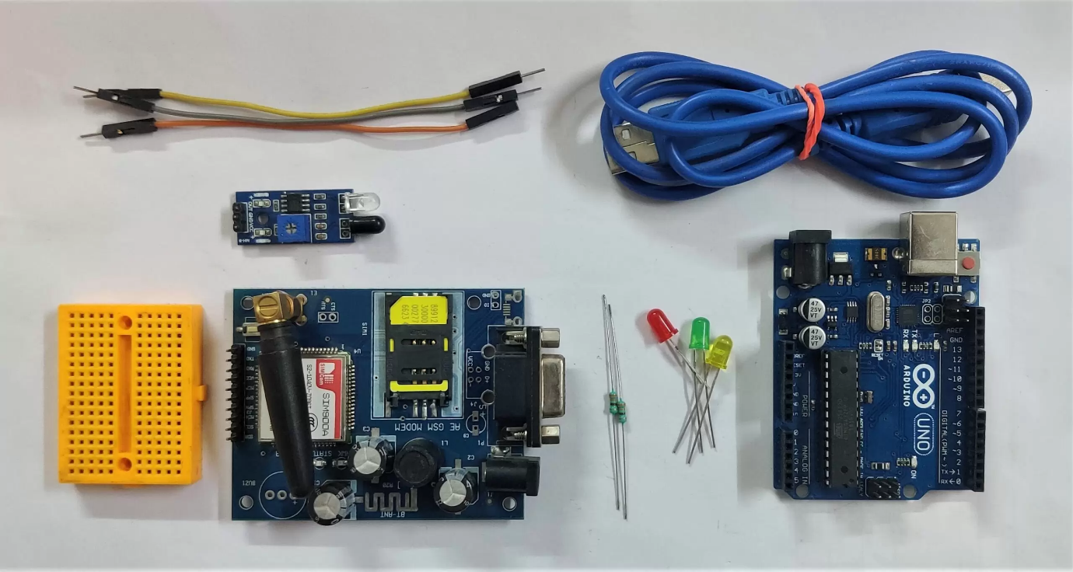

**Fig 3.6 Components**

**Future Plan**

Figure 3.3 : Overview of the System Framework

Figure 3.3 illustrates the entire system framework, detailing the process of turning the system on or off via SMS from a client's mobile phone. When the home security system is activated, it monitors the area using an IR (Infrared) sensor. If any obstacles or unauthorized movements are detected, the system sends a notification to the user's mobile phone via SMS and can also activate a siren alarm.

The demand for home security features has significantly increased due to rising concerns about safety and security. Homeowners are increasingly worried about protecting their homes from unauthorized individuals. Our system can monitor a house using sensors integrated with a microcontroller unit such as Arduino and a GSM modem unit. This system alerts the user via SMS when a potential intrusion is detected.

Given that nearly everyone today uses a mobile phone, this system provides the advantage of not requiring users to carry an additional device to monitor their homes. This is the primary benefit and feature of our project. The system is designed using a modular approach, allowing for flexibility and the addition of more sensors without altering the entire system. Simply adding a few sensors can enhance the system's functionality.

This design follows modern technology trends and is considered an advanced solution. It functions as a modular home security system, utilizing SMS capabilities to facilitate communication between the system and the user.

CHAPTER 4

CONCLUSION

This **GSM-based home security system** provides an affordable, reliable, and highly flexible solution for protecting homes from unauthorized entry. By combining **IR sensors** for accurate motion detection with **GSM technology** for real-time alerts, the system offers homeowners peace of mind, knowing that they will be immediately notified of any suspicious activity. Furthermore, the use of **Arduino microcontroller** ensures scalability, allowing the system to be expanded with additional sensors or features as needed, making it a robust, future-proof solution for modern home security.

This extended version adds more technical detail to help clarify how each component works within the system and how they integrate for effective home security. It highlights the adaptability and scalability of the system, making it a comprehensive, flexible solution. Let me know if you'd like to add more specifics or modify any sections!

REFERENCES

[1] T. Prathaban, W. Thean, and M. I. S. M. Sazali, “A vision-based home security system using opencv on raspberry pi 3,” in AIP Conference Proceedings, vol. 2173, AIP Publishing, 2019.

[2] A. Adriansyah and A. W. Dani, “Design of small smart home system based on arduino,” in 2014 Electrical Power, Electronics, Communica tons, Control and Informatics Seminar (EECCIS), pp. 121–125, IEEE, 2014

[3] J. W. Lartigue, C. McKinney, R. Phelps, R. Rhodes, A. D. Rice, and A. Ryder, “A tablet-controlled, mesh-network security system: An architecture for a secure, mesh network of security and automation systems using arduino and zigbee controllers and an android tablet application,” in Proceedings of the 2014 ACM Southeast Regional Conference, pp. 1–4, 2014.

[4] S. I. Azid and S. Kumar, “Analysis and performance of a low cost sms based home security system,” International Journal of Smart Home, vol. 5, no. 3, pp. 15–24, 2011.

[5] M. A. Baballe, M. I. Bello, B. A. Imam, A. T. Sule, and A. S. Muhammad, “Implementation of security alarm using arduino with pir motion sensor and gsm module,” Artificial & Computational Intelli gence, https://acors. org/ijacoi/VOL2 ISSUE2 8. pdf, pp. 1–7, 2021.

[6] L. H. Albak, A. Hamed, and R. R. O. Al-Nima, “Design security system based on arduino,” TEST Engineering & Management, The Mattingley Publishing Co., Inc, vol. 82, pp. 3341–3346, 2020.

[7] Q. I. Sarhan, “Arduino based smart home warning system,” in 2020 IEEE 6th International Conference on Control Science and Systems Engineering (ICCSSE), pp. 201–206, IEEE, 2020.

CERTIFICATES

**National Conference on Mindfulness, Spirituality and Technology (NCMST)**

**1.Harshal H. Mahajan**



**2.Kalpesh K. Patil**



**3.Aadesh S. Chaudhari**



**Workshop on Research Methodology**

**1.Harshal H. Mahajan**



**2.Kalpesh K. Patil**



**3.Aadesh S. Chaudhari**



**4.Aadesh S. Mhaske**

